## **DEPARTMENT OF ZOOLOGY SEMESTER V HONS**

## **“VISIT TO ZOOLOGICAL PARK TO STUDY ANIMAL BEHAVIOUR”**

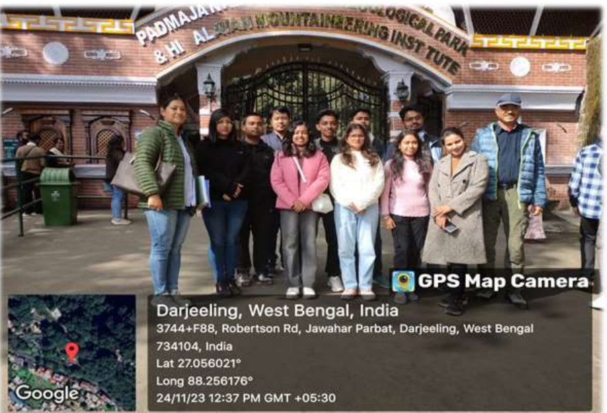

**The place of visit :-** **DARJEELING ZOO Padmaja Naidu Himalayan Zoological Park**

Padmaja Naidu Himalayan Zoological Park is located in the town of Darjeeling, West Bengal – 734101. It was situated at an average elevation of 7,000 feet (2,134m) above sea level, making this is the largest high altitude zoo in india. The Zoo is located at Birch Hill, which is about 1,5km from the main town of Darjeeling.

**Participants:** Students of 5th semester Honours,Zoology department.

**Accompanied by:** Zareth Rongong, Dr. Sushmika Pradhan,Mrs. Nupur Mondal, Mr. Biswarup Bhowmick

**Course**: DSE 2 Papers (Animal Behaviour and Chronobiology): Visit to a Zoological Park.

**Date of Visit:** We visited Darjeeling Zoo on 23rd November, 2023 -24th November 2024

**Objectives of Darjeeling Zoo Visit :**

1)To learn about Ex-situ Conservation & Captive breeding of endangered Himalayan animal

species.

2) Learning about educating, motivating and initiating awareness campaign among the local people as well as the visitors on the importance of conservation of Himalayan eco-system.

3)Collecting various information about applied research on animal biology, behaviour and health care

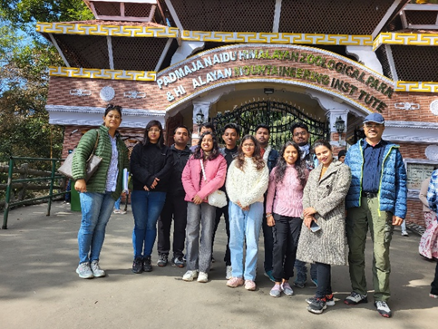

After reaching the Zoo, we were warmly welcomed by their team and since we were presenting our college, we were provided with a special guide, Zoobiologist of Darjeeling Zoo, Miss Ruma Ghosh throughout the session. They provided us with every inch of the details about how they manage the entire park and how the animal are being taken care. Also they had arranged a small interaction programme to tell us about their projects and research works and their future plannings for the park. Inside the Zoo, we had a great experience viewing the animals in such close proximity. At first we entered the herbivore section where we enjoyed watching deers especially Barking deer, Blue Sheep, Yak etc, different varieties of birds.

In the carnivore zone, starting with Snow Leopard, the Royal Bengal Tigers and lastly Red Panda. It was an astonishing fact to notice that the wild animals were accustomed by the visitors as they did not feel disturbed or show any kind of aggressive behaviours. Since, it was noon, most of the animals were in the mood of resting and sleeping. Within one hour we completed the tour. We were provided with various valuable information about different kinds of animals and the procedures required to keep them in a Zoo. The animals and bird species which are endangered or threatened are kept in captivity with full care to perform captive breeding to increase their numbers.

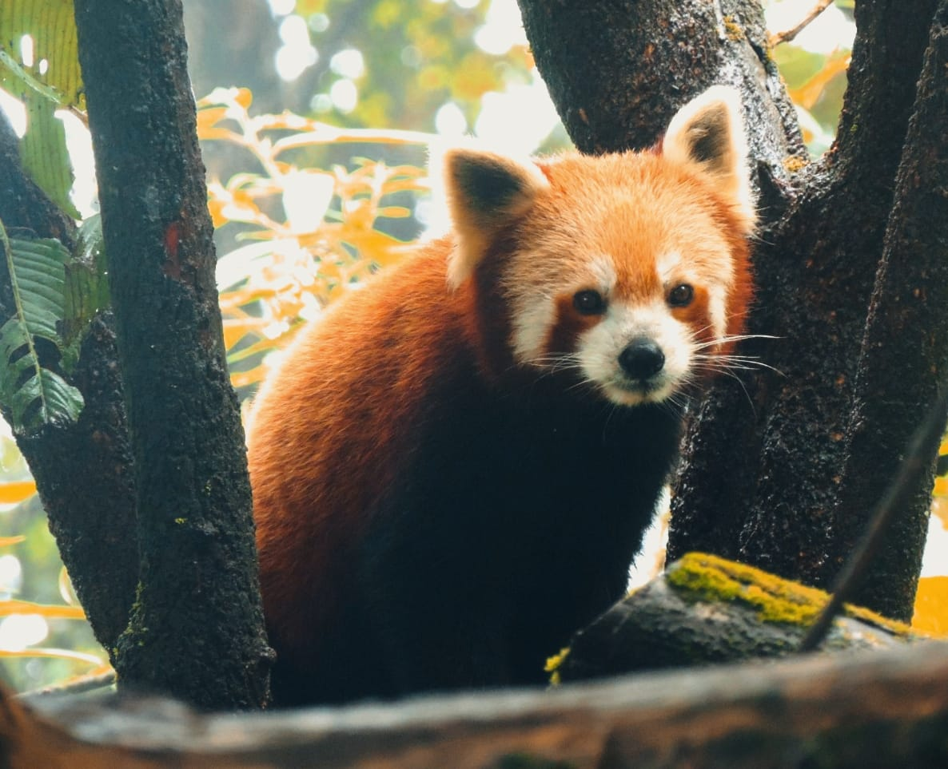

Fig: Red Panda In Darjeeling Zoo

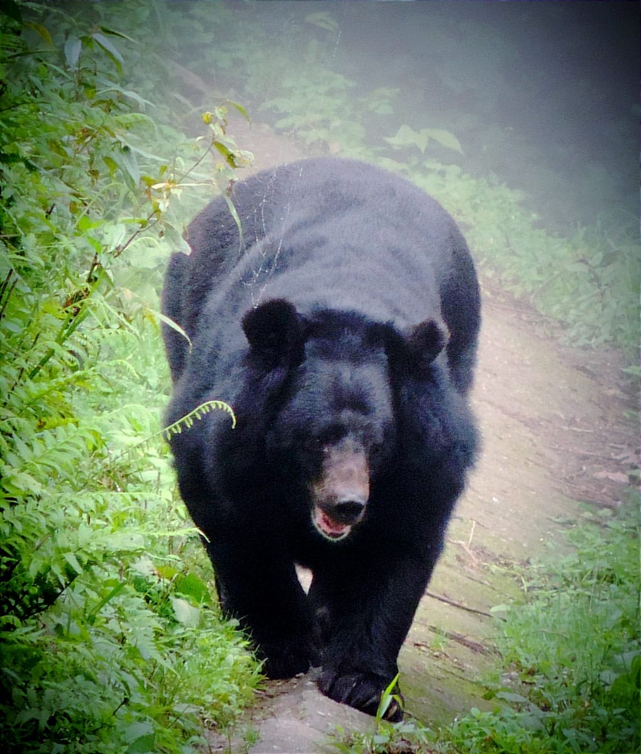

Fig: Himalayan Black Bear